 | Design Strategist
 | Angelina Russo, MBA
Curriculum Vitae | 2019
Key Skills  - Leadership  - Research Management  - Design  - Innovation  - Communication  - Social Media  Popular Articles  Beyonce and the cultural lure of sweat  Utopia. Seriously good urban planning should aspire to it  London’s SkyCycle bike route – elevation of the white male elite?  Re-imagining Australia by bike  Qualifications  PhD. Architecture and Design, University of South Australia  MBA Higher Education Management University College London, UK  Bachelor of Design, Human Environment Design, University of South Australia  Certificate of Digital Marketing , Anthill Enterprises  Certificate of Production Design Australian Film Television and Radio  Influence  I have been invited to deliver over 70 keynote presentations nationally and internationally on some of the following subjects:  The Future of Museums  Museums as Creative Incubators  STEM/STEAM education and digital fabrication  Creativity and maker spaces  Innovation and cultural institutions  Embracing Innovation  Transformations in Cultural Leadership  Media  CultureCycle Fashion Award  The future of crowdsourcing  Urban cycling futures  Events Hosted  Transformations in Cultural Leadership 2016  Transformations in Cultural Communication (2008,09,11)  Contact  www.makingmakers.space  Business Cases  Report Writing  Budgets | Summary  I am an internationally design strategist with more than 100 publications, 4 national awards and 25 years of experience in cultural research /teaching and design practice. I am regularly invited to provide leadership to the cultural sector and my grant writing has resulted in over $12m in grants over 12 years.  Email:angelina@makingmakers.space  Mobile: +61 447177860  Skype: artech051  I am known for my entrepreneurial approach to strategy. I consult to businesses ranging from environmental sustainability to textile futures. I am recognised for my ability to bring together new technologies and teams to support innovation across multiple sectors.  I am an invited scholar in the award-winning Exertion Games Lab, RMIT University, an invited Associate Scholar in the Centre for Research in Digital Education, Moray House, University of Edinburgh and a former Board Member of CraftACT.  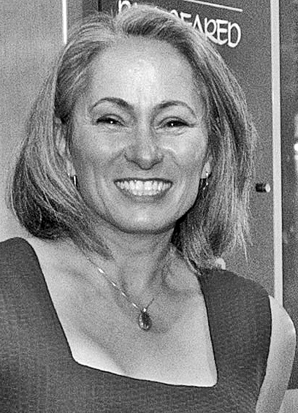  I have a PhD in Architecture and Design, an MBA from University College London (2014) and a Cert 4 in Small Business Management.  I am recognised for my social enterprise experience as a co-founder of the 4000 member global network, Museum3 which provided an invaluable resource to the cultural sector.  I have held leadership roles in academia including: Associate Dean Research, University of Canberra; Director of Higher Degrees Research, RMIT University; Chief Investigator, ARC Centre of Excellence for Creative Industries and Innovation and Head of Communication Design, Queensland University of Technology. I have received national and international awards including: Queensland Premiers' Smithsonian Fellowship (undertaken in New York); Australian Post-graduate Industry Awards (resulting in 1.1millionAUD grant); Australian Wool Fashion Awards (first prize, twice). I am a former member of the Fulbright Scholarship Committee, an Australian Research Council Assessor and a member of Australian Institute of Company Directors (AICD).  Employment History  2019 Design Strategist, Making Makers  2018 Senior Grants Coordinator, DSC, RMIT  2017 Co-Director FABRICATE STUDIO  2012-2015 Professor of Cultural Practice and Associate Dean Research, Univeristy of Canberra  2010 – 2013 Associate Professor and Director, Higher Degrees Research, RMIT University  2006 – 2011 Chief Investigator Australian Research Council Centre of Excellence in Creative Industries and Innovation  2011 – 2016 Director, Museum3Ltd  2008-2010 Associate Professor, Swinburne University  2003 – 2007 Head of Communication Design, Smithsonian Fellow and Senior Research Fellow. Creative Industries Faculty, Queensland University of Technology.  Grants  Australian Research Council Cash and inkind $1.2million LP0562264  New Literacy, New Audiences  Australian Research Council Cash and inkind $1.1million LP0776236  Engaging with Social Media in Museums  ACT Innovation Council Cash $350,000  Newcastle City Council Cash $130,000  I have consulted to a number of competitive grants to the combined value of over 12millionAUD.  Awards  2005 Queensland Premiers’ SMITHSONIAN FELLOWSHIP  2005 Australian Research Council Postdoctoral Fellowship  2016 First Prize, KNITWEAR, Australian Wool Fashion Awards  2011 First Prize, KNITWEAR, Australian Wool Fashion Awards  Publications  Book chapters  I am widely published and over the past 15 years I have been invited to contribute book chapters to key publications in the areas of:  Social media in museums, Media in the Threshold Experience  New modes of knowledge production:Makerspaces & maker practices  Communications marketing and management  Journal Articles  I have been invited to contribute to numerous journals in areas of transformation in cultural communication  Social media and cultural interactive experiences  marketing and product placement  Refereed Conference Papers  I’ve been invited to present over 50 conference papers around the world on subjects ranging from 3d food printing to multiplatform digital content creation  FOR MORE, SEE https://www.researchgate.net/profile/Angelina_Russo  I have delivered a number of Business Cases to government agenices  and institutions. I can provide examples that demonstrate my ability to draw together resources, analyse data and make recommendations  I can provide examples that demonstates my ability to both analyse and summarise business informatics and then contextualise this within broader sectors  I am extremely adept at preparing and managing research budgets having aquitted over $2mAUD in personal research grants. I have also held budget responsibility of just over $1m each year for the past 5 years.  I can provide examples of multi-partner, multi-instutitonal grants including budget, quotes and budget justification.

